

# **User's Guide**

# **Adopt 1 Candidate**

**Team 2**

Table of contents

User's Guide 1

Adopt 1 CandidAT 1

Introduction 3

Overview of Adopt1Candidate 3

Installation and configuration 3

To create an account 5

Understand the dashboard 6

Safety 7

Password management 7

Modification of profile information 7

Use Adopt1Candidate 8

Navigation in profiles 8

Swiping and Matching 8

Communicate with matched people 9

Troubleshooting and assistance 10

FAQ 10

How do I delete my account? 10

How does the pating algorithm work? 11

Common problems and solutions 12

Contact support 12

# **Introduction**

## **Overview of Adopt1Candidate**

Adopt1Candidat is an innovative application designed to connect employees and employers via a user-friendly interface based on the swipping, similar to dating applications.

The platform aims to simplify job search and recruitment processes by allowing users to quickly browse profiles and find appropriate matches while maintaining anonymity until a correspondence is made. Key features include browsing profiles, swipping for correspondence, instant messaging and notifications.

## **Installation and configuration**

**Requirements:**

To ensure optimal performance, Adopt1Candidat requires the specifications system following:

For mobile devices :

* iOS 16.0 or version Later
* Android 8.0 (Oreo ) or version Later

For web browsers:

* Latest Versions of Chrome, Firefox, Safari or Edge

Minimum Equipment :

* 2GB of RAM
* 200 MB of available storage space
* Stable internet connection

**Download The application:**

📱 **iOS** : Go to the AppStore From Apple and search for "Adopt1Candidate". Press the download button to install the application.

🤖 **Android** : Go to the Google Play Store and search for "Adopt1Candidate". Press the download button to install the application.

**Initial configuration:**

* **Open** the application after the installation.
* **Choose** "Create An account" and follow the instructions at the Screen For you record.
* **Check**  Your aSend an e-mail by clicking on the link Send ́ in your Box Of Reception.
* **Log in** A ̀ the help of your address Electronic And your password.

## 

## **To create An account**

* **Open** The application and Select " Continue with an email".

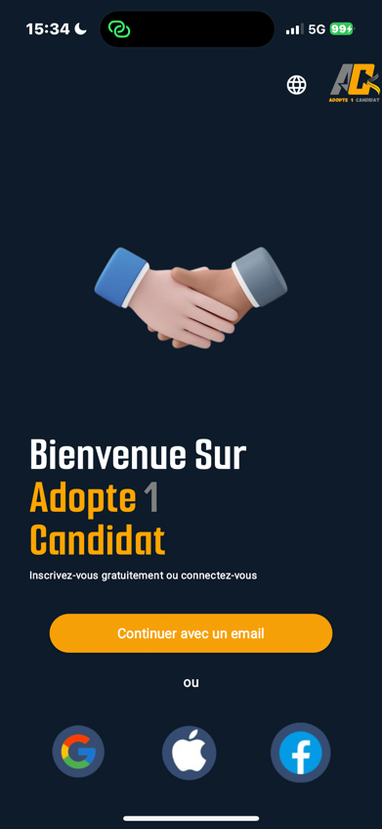

* **Select** "Register".

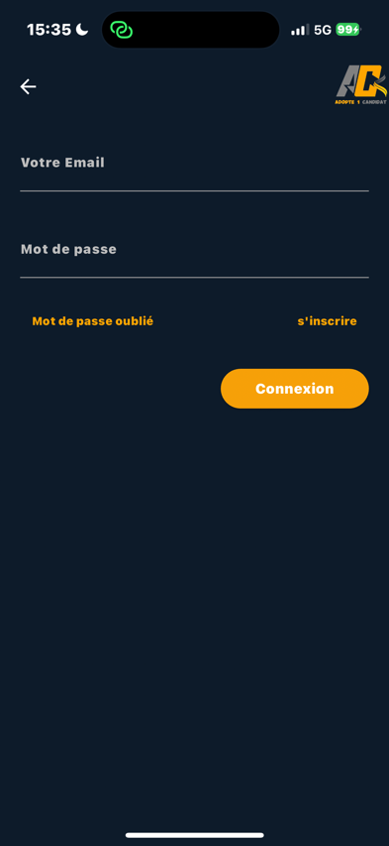

* **Select** The type of profile that suits you

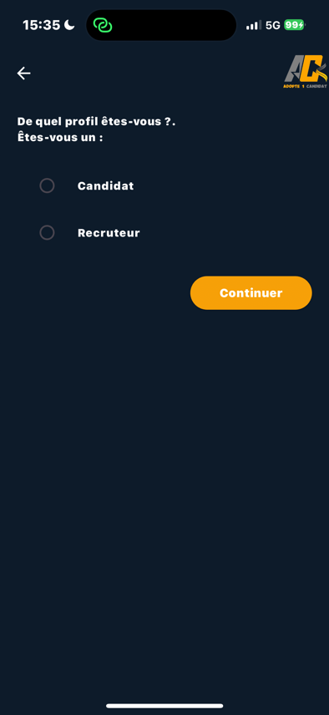

* **Enter** the necessary information A Your registration.
* **Log in** with the help of your email adress and your password.

**Comment**

* The contact details remain anonymous until a mutual correspondence is established!

## **Understand the dashboard**

#### **The dashboard contains Elements Essential**

* **Reception** : Your profile management center, Likes And messages.
* **Matches** : See the users who haveShowń of theInterest For your profile After That a correspondence has St. ́ Established.
* **Messages** : Engage in a messaging systemInstant With matches once anonymity Reveaĺ.

# **Safety**

## **Password management**

**Changing your password:**

1. **Come on** In the nailT "Settings" in "Profile".

**Tips for a strong password:**

1. **Use** A combination of letters (uppercase and lowercase), numbers, and symbols.
2. **Avoid** To use personal informationObvious things such as your name, date of birth, or common words.
3. **Try** To use at least 12 characters. The longer your password, the more secure it is.
4. **Change** RegularEment your password and do not reuse old passwords

## **Modification of profile information**

* **Come on** In the "Profile" tab and click on "Edit profile".
* **Put** Update your dataPersonal and professional if necessary.
* **Modify** Your profile picture by tapping the photo icon and selecting a new image.

# **Use Adopt1Candidate**

## **Navigation in profiles**

* **Open** The tab "Swap "To start browsing profiles anonymously.
* **Use** Filtering options to refine your search based on criteria such as location, title of thePosition, sector of activity and experience.
* **Type** On a profile to display more details about the user.

## **Swiping And Matching**

**Swiping :**

* Slide towards the Right To like a profile.

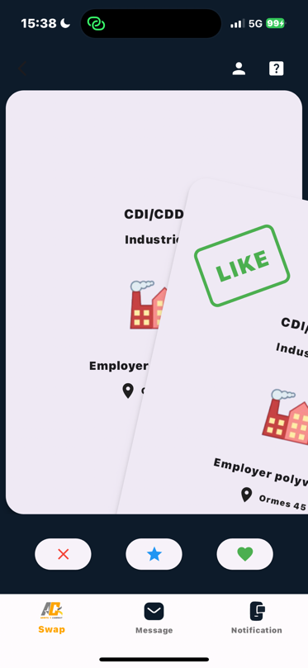

* Slide towards the Left To switch to a profile.

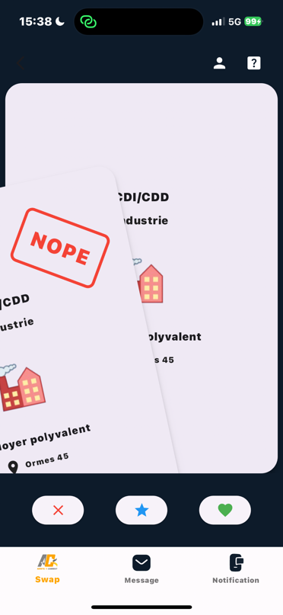

**Matching :**

* If both parties slide their finger towards the Right, aCorrespondence is created and anonymity is lifted.
* Correspondences are notified instantly and moved to the tab " Message ».

## **Communicate with matched people**

* **Open** The tab "Message " and select a correspondent to start a conversation. Communicate with correspondents
* **Use** The chat interface to send messages.
* **Join** Files, such asOnly CVs or job descriptions, to your messages.
* **Organize** Interviews or meetings Through the messaging of our application.

# **Troubleshooting and assistance**

## **FAQ**

**Can I change my email address?**

**To change your email address**

1. **Come on** In the "Account Settings" section in "Profile".
2. **Search for** The option allowing you to update your email address.
3. **Enter** Your new email address and follow any additional verification steps.
4. **Take care** To save the changes once you have updated your email address.

# **How do I delete my account?**

#### **To delete your account**

1. **Come on** In the "Account Settings" section in "Profile".
2. **Search for** The option at the bottom to delete your account.
3. **Follow** The instructions toThe screen to confirm the deletion.
4. **Note** That this action is irreversible. So make sure you want to delete your account permanently.

# **How does the pating algorithm work?**

The AMatching algorithm works by analyzing the information provided in user profiles for To suggest Potential correspondences Based On the Compatibilitý. Here's how it worksGenerally :

1. **Profile information:** Users provide Details On Themselves , such as their Interest , their Preferences And their Characteristics.
2. **Criteria Of pairing:**  The algorithm uses Criteria Predefined PoTo match users, such as the Age, the location, the centers ofInterest And the attributes Desired In a correspondence.
3. **Score of Compatibilitý :** The algorithm calculates a score ofCompatibility ́ for each potential candidate according to the CompatibilityOf their respective profiles.
4. **Recommendations:** Users are then offered a list of matchesRecommended , Classified According to their score of Compatibilitý.
5. **User comments:** Users can give their opinion on the connections inMagnet or by transmitting them, which makes it possible to refine the algorithm over time to provide more recommendations Precise.

Overall, the pairing algorithm aims to A ̀ put in relAtion users with compatible people on the basis of their Preferences And information from their profile.

## **Common problems and solutions**

**Connection problems :**

* **Make sure** That you use the correct email address and password.
* **To reboot** Your password if you have forgotten it.

**Profile configuration problems :**

* **Make sure** That all mandatory fields are filled in.
* **Check** Your email address if you have not already done so.

## **Contact support**

**Channels of Support:**

* **Send** OneEmail to support at support@adopt1candidat.com
* **Telephone support** From 9am to 5pm J /7.

**Report b Ugs :**

* **Use** The "Report a problem" function in the tab “ Parameters".
* **To provide** A detailed description of the problem and the steps to reproduce it.